1. Introduction
  - Project Overview
DocSpot is a full-stack web application developed using the MERN stack (MongoDB, Express.js, React.js, Node.js). It enables patients to search for doctors, book appointments, upload medical documents, and receive notifications. Doctors can manage schedules and appointments, while admins monitor and approve registrations.

  - Purpose
The purpose of DocSpot is to simplify healthcare appointment booking by providing:
- Easy doctor discovery
- Online appointment scheduling
- Secure document uploads
- Role-based dashboards (Admin, Doctor, Patient)
- Secure authentication using JWT and bcrypt

2. IDEATION PHASE
2.1 Problem Statement
Traditional hospital appointment systems are:
- Time-consuming
- Manual and paperwork-heavy
- Difficult to manage
- Lack real-time availability updates
Patients face long waiting times and poor communication with doctors.
2.2 Empathy Map Canvas Patients Think:
- “I need quick appointment booking.”
- “I don’t want to stand in queues.”
Patients Feel:
- Frustrated with delays
- Worried about missing appointments
Patients Say:
- “Why is booking so complicated?”
Patients Do:
- Call hospitals repeatedly
- Visit hospitals physically for booking
2.3 Brainstorming
We discussed solutions like:
- Online appointment system
- Real-time availability display
- Notification system
- Secure login system
- Role-based dashboards
Final idea selected: DocSpot Platform

3. REQUIREMENT ANALYSIS
3.1 Customer Journey Map
- User registers
- User logs in
- Searches doctor
- Books appointment
- Uploads documents
- Receives confirmation
- Views booking history
3.2 Solution Requirement
Functional Requirements:
- User registration/login
- Doctor search & filter
- Appointment booking
- Admin approval system
- Document upload
Non-Functional Requirements:
- Secure authentication
- Fast response time
- Responsive UI
- Data encryption
3.3 Data Flow Diagram (Text Explanation)
User → Frontend (React) → Backend (Express API) → MongoDB Database → Response back to User
3.4 Technology Stack
- Frontend: React.js
- Backend: Node.js, Express.js
- Database: MongoDB
- Authentication: JWT
- Password Security: bcrypt
- API Testing: Postman
- Version Control: Git

4. ROJECT DESIGN
4.1 Problem Solution Fit
DocSpot directly solves the difficulty in booking healthcare appointments by offering a digital platform with real-time availability and secure access.
4.2 Proposed Solution
A MERN-based web platform that:
- Connects patients & doctors
- Manages appointments digitally
- Provides admin governance
- Ensures security & performance
4.3 Solution Architecture
Three-tier architecture:
- Presentation Layer → React Frontend
- Application Layer → Node + Express Backend
- Data Layer → MongoDB Database
5. PROJECT PLANNING & SCHEDULING
5.1 Project Planning
- Week 1 → Requirement analysis
- Week 2 → Database design & backend setup
- Week 3 → Frontend development
- Week 4 → Integration & testing
- Week 5 → Documentation & deployment
6. FUNCTIONAL AND PERFORMANCE TESTING
6.1 Performance Testing
- Verified authentication security
- Tested API endpoints using Postman
- Load tested multiple concurrent users
- Tested file upload functionality
- Verified role-based access

7. RESULTS
7.1 Output Screenshots
- Landing Page : Welcoming interface for users.

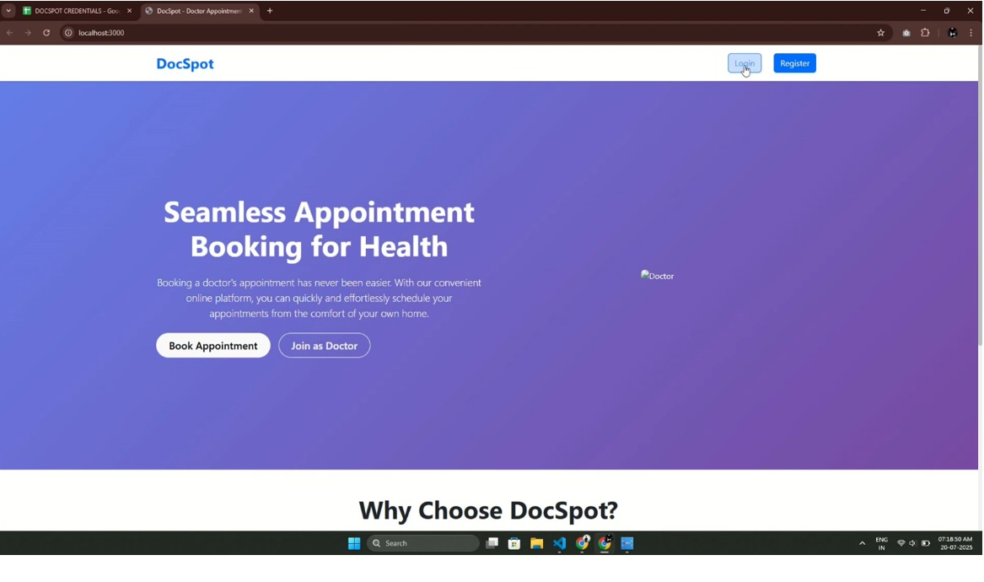
- Login Page : Secure login interface.

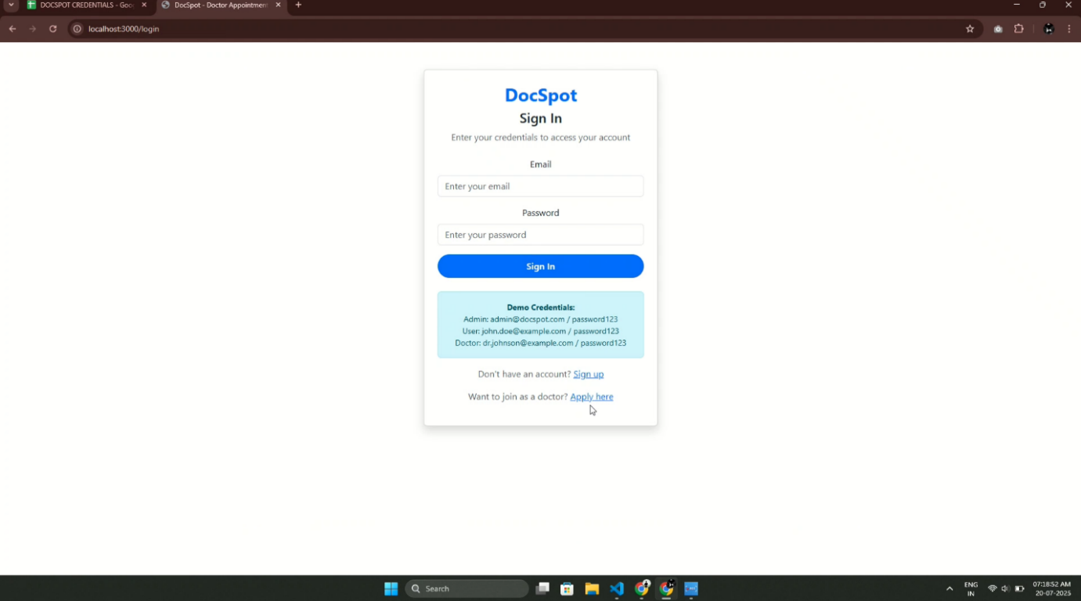

- User Dashboard : Patient interface for browsing and booking.

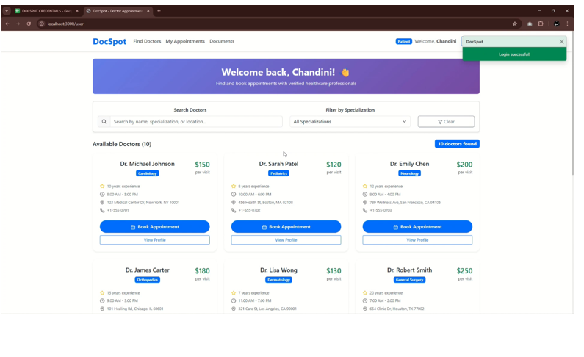
- Doctor Dashboard : Appointment and patient management for doctors

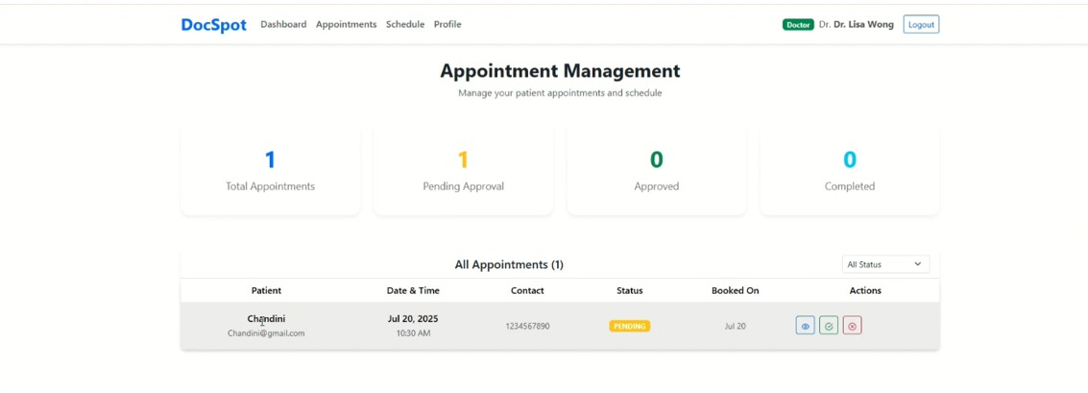

Admin Dashboard : Overview for platform management.
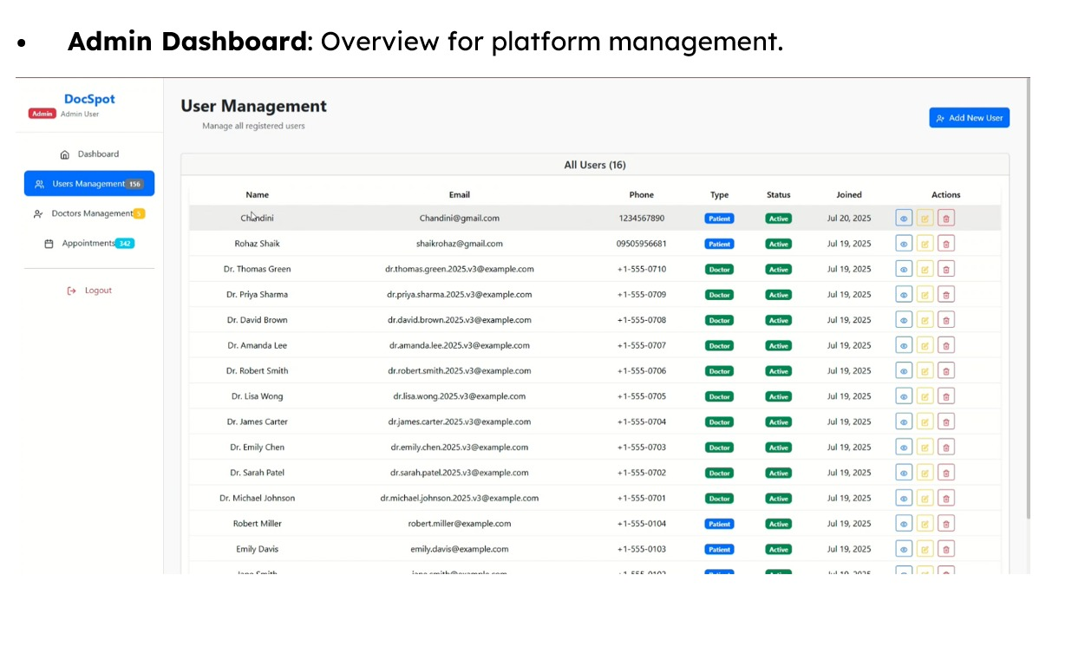
- Book Appointment Page : Appointment booking form

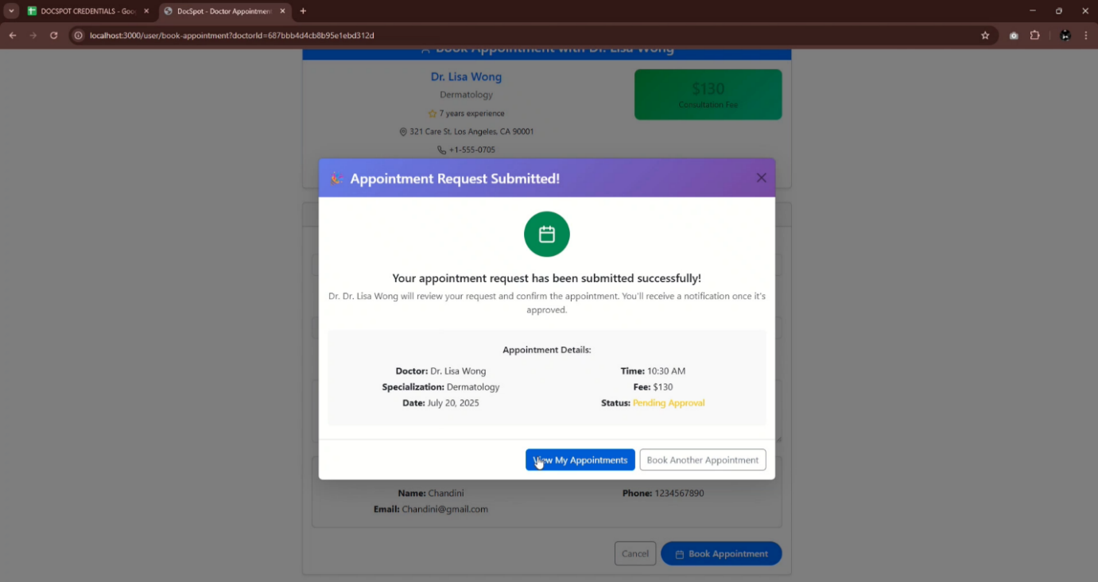

- Booking History Page : Booking history for users.
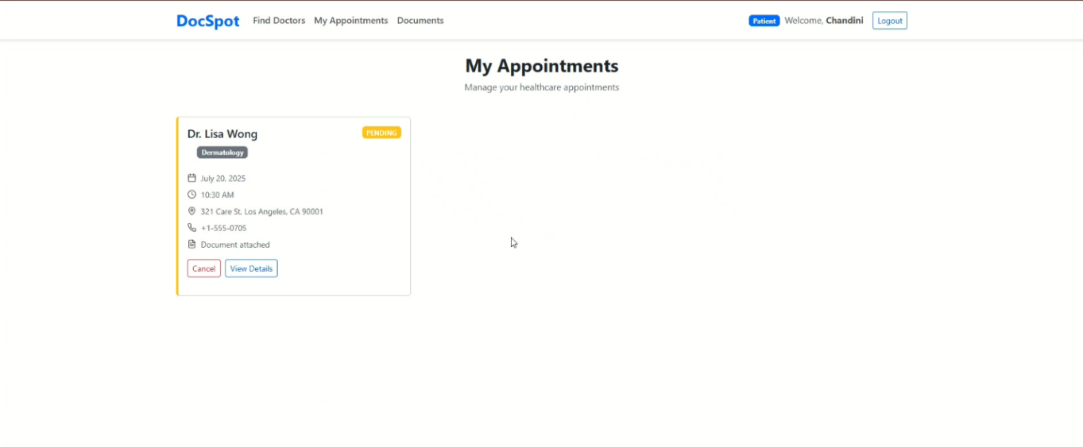

8. ADVANTAGES & DISADVANTAGES
Advantages
- Saves time
- Easy booking
- Secure authentication
- Role-based control
- Document management
Disadvantages
- Requires internet access
- SMS/email delays under heavy load
- No direct rescheduling feature

9. CONCLUSION
- DocSpot successfully implements a secure and scalable healthcare appointment system using the MERN stack. It simplifies doctor discovery, appointment scheduling, and administrative control, providing a seamless experience for patients, doctors, and administrators.
10. FUTURE SCOPE
- Direct appointment rescheduling
- Online payment integration
- AI-based doctor recommendation
- Mobile application (Android & iOS)
- Real-time chat system
- Multi-language support

11. APPENDIX
Source Code :
https://github.com/chaitanyaponnada/Docspot-seamless-appointment-booking
Dataset Link :
Not applicable (uses MongoDB live database)
GitHub & Project Demo Link
Demo: https://drive.google.com/file/d/18C61itAUcULcNt8OR3e2nthye2zoJcSr/view

